Experiment-4
SIMULATION EXPERIMENT – 5
❖ Realization of IIR Filters Using Direct Form-I, Direct Form-II, Cascade and Parallel Structures Using MATLAB
CO Mapping:CO1
Blooms Level K5-Evaluate
WK Level :WK4- Engineering Design (Evaluates alternative filter designs against specifications)
➔ Major Topic
IIR Realization Structures
➔ Minor Topics
1. To realize a specified IIR filter using Direct Form-I and Direct Form-II structures in MATLAB.
➔ Objectives of this Experiment:
1. To realize a given IIR transfer function using Direct Form-I and Direct Form-II structures.
2. To obtain cascade realization using second-order sections.
3. To obtain parallel realization using partial-fraction decomposition.
4. To compare the realized structures using coefficients, impulse/output responses and implementation characteristics.
➔ Expected Outcome from this Experiment:
Students shall be able to:
1. Construct Direct Form-I and Direct Form-II realizations from the same IIR transfer function.
2. Obtain second-order-section coefficients for cascade realization.
3. Obtain parallel branches using partial-fraction decomposition and verify their combined response.
4. Compare the output responses of all realizations and confirm that equivalent structures implement the same transfer function within numerical tolerance.
➔ Software Required:
MATLAB with Signal Processing Toolbox.
➔ Objective linkage:
The experiment is structured so that each objective directly produces a verifiable output listed in the Output Parameter Table.
➔ Experimental Procedure:
1. Select a stable IIR filter and obtain its numerator and denominator coefficient vectors.
2. Implement the transfer function in Direct Form-I and Direct Form-II using MATLAB-compatible difference equations or realization functions.
3. Convert the filter to second-order sections and construct the cascade realization.
4. Perform partial-fraction decomposition and construct the parallel realization.
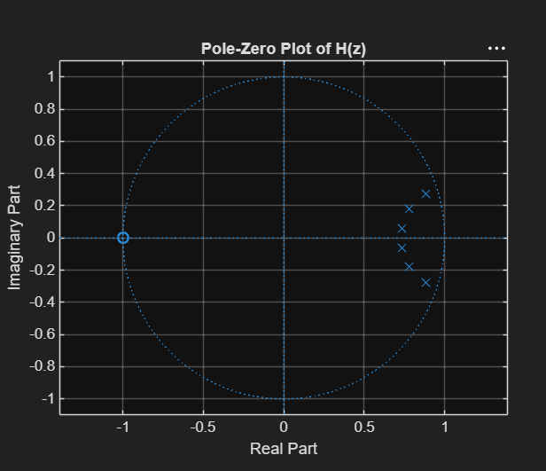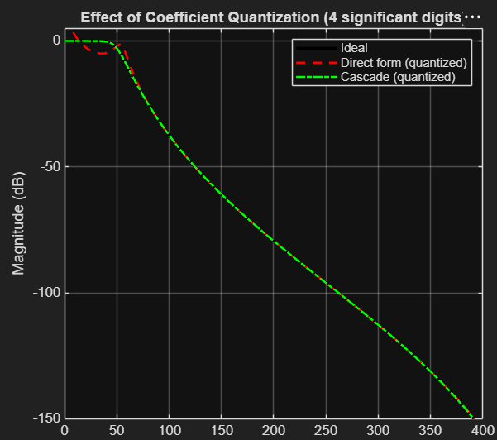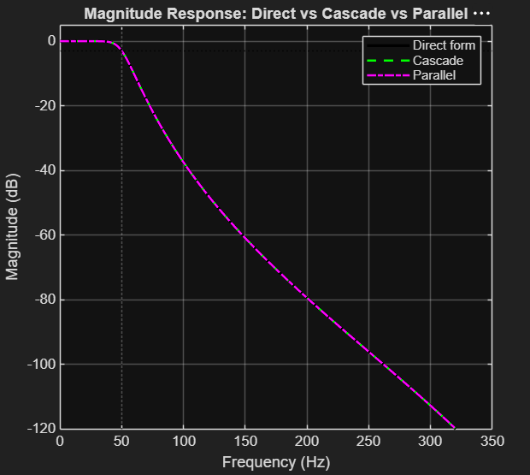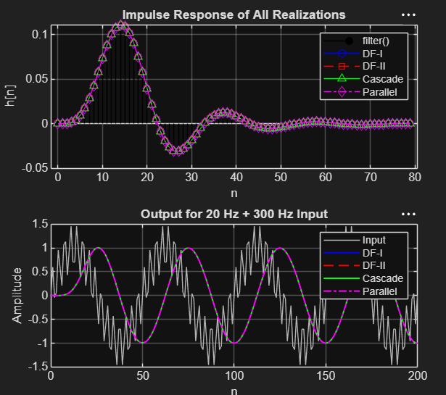
%% Experiment 5: Realization of IIR Filters (DF-I, DF-II, Cascade, Parallel)
clc; clear; close all;

%% 1. Select a stable IIR filter
Fs = 1000; fc = 50; N = 6;
[b, a] = butter(N, fc/(Fs/2)); % H(z) = B(z)/A(z)

disp('--- Transfer function coefficients ---');
disp('b ='); disp(b);
disp('a ='); disp(a);
fprintf('Stable? %d (max |pole| = %.5f)\n', all(abs(roots(a))<1), max(abs(roots(a))));

%% 2. Test inputs
L = 400; n = 0:L-1;
x_imp = [1 zeros(1, L-1)]; % impulse
x_sig = sin(2*pi*20*n/Fs) + 0.5*sin(2*pi*300*n/Fs); % 20 Hz + 300 Hz

%% 3. Direct Form-I (separate input and output delay lines)
% y[n] = sum b(k+1) x[n-k] - sum a(k+1) y[n-k]
dfI = @(b,a,x) df1_run(b,a,x);

%% 4. Direct Form-II (one shared delay line w[n])
% w[n] = x[n] - sum a(k+1) w[n-k]; y[n] = sum b(k+1) w[n-k]
dfII = @(b,a,x) df2_run(b,a,x);

yI_imp = dfI (b, a, x_imp); yI_sig = dfI (b, a, x_sig);
yII_imp = dfII(b, a, x_imp); yII_sig = dfII(b, a, x_sig);

%% 5. Cascade realization (second-order sections)
[sos, g] = tf2sos(b, a);
sos(1,1:3) = sos(1,1:3)*g; % absorb overall gain into section 1
nSec = size(sos,1);
disp('--- Cascade: SOS matrix [b0 b1 b2 a0 a1 a2] ---'); disp(sos);

casc = @(x) cascade_run(sos, x);
yC_imp = casc(x_imp); yC_sig = casc(x_sig);

%% 6. Parallel realization (partial fractions in z^-1)
[r, p, k] = residuez(b, a); % H(z) = k + sum r_i/(1 - p_i z^-1)
tol = 1e-8;
used = false(size(p));
Bp = []; Ap = []; % each row = one real second-order branch
for i = 1:numel(p)
if used(i), continue; end
if abs(imag(p(i))) < tol % real pole -> first-order branch
Bp = [Bp; real(r(i)) 0 0];
Ap = [Ap; 1 -real(p(i)) 0];
used(i) = true;
else % complex-conjugate pair -> 2nd-order branch
j = find(~used & abs(p - conj(p(i))) < 1e-6, 1);
Bp = [Bp; 2*real(r(i)) -2*real(r(i)*conj(p(i))) 0];
Ap = [Ap; 1 -2*real(p(i)) abs(p(i))^2];
used([i j]) = true;
end
end
if isempty(k), k = 0; end
disp('--- Parallel: direct term k ---'); disp(k);
disp('--- Parallel branches ---');
disp('Numerators [c0 c1 c2] ='); disp(Bp);
disp('Denominators [1 d1 d2] ='); disp(Ap);

par = @(x) parallel_run(Bp, Ap, k, x);
yP_imp = par(x_imp); yP_sig = par(x_sig);

%% 7. Reference output from MATLAB filter()
yR_imp = filter(b, a, x_imp); yR_sig = filter(b, a, x_sig);

%% 8. Output responses of all realizations
figure;
subplot(2,1,1);
stem(n(1:80), yR_imp(1:80), 'k', 'filled'); hold on;
plot(n(1:80), yI_imp(1:80), 'b-o'); plot(n(1:80), yII_imp(1:80), 'r--s');
plot(n(1:80), yC_imp(1:80), 'g-^'); plot(n(1:80), yP_imp(1:80), 'm-.d');
grid on; legend('filter()','DF-I','DF-II','Cascade','Parallel');
title('Impulse Response of All Realizations'); xlabel('n'); ylabel('h[n]');

subplot(2,1,2);
plot(n, x_sig, 'Color', [0.7 0.7 0.7]); hold on;
plot(n, yI_sig, 'b', n, yII_sig, 'r--', n, yC_sig, 'g', n, yP_sig, 'm-.', 'LineWidth', 1.2);
grid on; xlim([0 200]); legend('Input','DF-I','DF-II','Cascade','Parallel');
title('Output for 20 Hz + 300 Hz Input'); xlabel('n'); ylabel('Amplitude');

%% 9. Frequency responses of the structures
nfft = 2048;
[Hd, f] = freqz(b, a, nfft, Fs);
Hc = ones(nfft,1);
for s = 1:nSec, Hc = Hc .* freqz(sos(s,1:3), sos(s,4:6), nfft, Fs); end
Hp = k * ones(nfft,1);
for s = 1:size(Bp,1), Hp = Hp + freqz(Bp(s,:), Ap(s,:), nfft, Fs); end

figure;
plot(f, 20*log10(abs(Hd)), 'k', 'LineWidth', 2); hold on;
plot(f, 20*log10(abs(Hc)), 'g--', 'LineWidth', 1.5);
plot(f, 20*log10(abs(Hp)), 'm-.', 'LineWidth', 1.5);
grid on; ylim([-120 5]); xline(fc, ':k'); yline(-3, ':k');
legend('Direct form', 'Cascade', 'Parallel');
title('Magnitude Response: Direct vs Cascade vs Parallel');
xlabel('Frequency (Hz)'); ylabel('Magnitude (dB)');

%% 10. Equivalence check (within numerical tolerance)
err = @(y,yr) max(abs(y - yr));
fprintf('\n--- Max |error| vs filter() (impulse input) ---\n');
fprintf('DF-I : %.3e\n', err(yI_imp, yR_imp));
fprintf('DF-II : %.3e\n', err(yII_imp, yR_imp));
fprintf('Cascade : %.3e\n', err(yC_imp, yR_imp));
fprintf('Parallel : %.3e\n', err(yP_imp, yR_imp));
fprintf('--- Max |error| vs filter() (sinusoid input) ---\n');
fprintf('DF-I : %.3e\n', err(yI_sig, yR_sig));
fprintf('DF-II : %.3e\n', err(yII_sig, yR_sig));
fprintf('Cascade : %.3e\n', err(yC_sig, yR_sig));
fprintf('Parallel : %.3e\n', err(yP_sig, yR_sig));
fprintf('Frequency-response mismatch Cascade: %.3e Parallel: %.3e\n', ...
max(abs(Hc-Hd)), max(abs(Hp-Hd)));
tolr = 1e-9;
fprintf('All structures equivalent (tol %.0e)? %d\n', tolr, ...
all([err(yI_imp,yR_imp) err(yII_imp,yR_imp) err(yC_imp,yR_imp) err(yP_imp,yR_imp)] < tolr));

%% 11. Implementation characteristics
M = numel(b)-1; D = numel(a)-1;
mult_DF = (M+1) + D; add_DF = M + D; % DF-I and DF-II
mult_C = 5*nSec; add_C = 4*nSec; % 5 mult, 4 add per biquad
nB = size(Bp,1);
mult_P = 3*nB + 2*nB + 1; add_P = 3*nB; % rough count, 2nd-order branches
fprintf('\n=========== IMPLEMENTATION COMPARISON ===========\n');
fprintf('%-12s %12s %12s %12s\n', 'Structure', 'Delays', 'Multipliers', 'Adders');
fprintf('%-12s %12d %12d %12d\n', 'Direct I', M + D, mult_DF, add_DF);
fprintf('%-12s %12d %12d %12d\n', 'Direct II', max(M,D), mult_DF, add_DF);
fprintf('%-12s %12d %12d %12d\n', 'Cascade', 2*nSec, mult_C, add_C);
fprintf('%-12s %12d %12d %12d\n', 'Parallel', 2*nB, mult_P, add_P);

%% 12. Coefficient quantization (4 significant digits) - sensitivity
q = @(x,d) sign(x).*round(abs(x).*10.^(d-1-floor(log10(abs(x)+(x==0))))) ...
.*10.^-(d-1-floor(log10(abs(x)+(x==0))));
bq = q(b,4); aq = q(a,4);
Hq_d = freqz(bq, aq, nfft, Fs);

Hq_c = ones(nfft,1);
for s = 1:nSec
Hq_c = Hq_c .* freqz(q(sos(s,1:3),4), q(sos(s,4:6),4), nfft, Fs);
end

figure;
plot(f, 20*log10(abs(Hd)), 'k', 'LineWidth', 2); hold on;
plot(f, 20*log10(abs(Hq_d)), 'r--', 'LineWidth', 1.5);
plot(f, 20*log10(abs(Hq_c)), 'g-.', 'LineWidth', 1.5);
grid on; ylim([-150 5]);
legend('Ideal', 'Direct form (quantized)', 'Cascade (quantized)');
title('Effect of Coefficient Quantization (4 significant digits)');
xlabel('Frequency (Hz)'); ylabel('Magnitude (dB)');

fprintf('\n--- Quantized structures ---\n');
fprintf('Direct form: max |pole| = %.5f, stable = %d, max response error = %.3e\n', ...
max(abs(roots(aq))), all(abs(roots(aq))<1), max(abs(Hq_d-Hd)));
fprintf('Cascade : max response error = %.3e\n', max(abs(Hq_c-Hd)));

%% 13. Pole-zero plot
figure; zplane(b, a); grid on; title('Pole-Zero Plot of H(z)');

%% ------------------------ Local functions ------------------------
function y = df1_run(b, a, x)
b = b(:).'/a(1); a = a(:).'/a(1);
M = numel(b)-1; D = numel(a)-1;
y = zeros(size(x));
for n = 1:numel(x)
acc = 0;
for kk = 0:M
if n-kk >= 1, acc = acc + b(kk+1)*x(n-kk); end
end
for kk = 1:D
if n-kk >= 1, acc = acc - a(kk+1)*y(n-kk); end
end
y(n) = acc;
end
end

function y = df2_run(b, a, x)
b = b(:).'/a(1); a = a(:).'/a(1);
K = max(numel(b), numel(a)) - 1;
b = [b zeros(1, K+1-numel(b))]; a = [a zeros(1, K+1-numel(a))];
w = zeros(1, K+1); % w(1)=w[n], w(2)=w[n-1], ...
y = zeros(size(x));
for n = 1:numel(x)
w(1) = x(n) - sum(a(2:end).*w(2:end));
y(n) = sum(b.*w);
w(2:end) = w(1:end-1); % shift delay line
end
end

function y = cascade_run(sos, x)
y = x;
for s = 1:size(sos,1)
y = df2_run(sos(s,1:3), sos(s,4:6), y);
end
end

function y = parallel_run(Bp, Ap, k, x)
y = k*x;
for s = 1:size(Bp,1)
y = y + df2_run(Bp(s,:), Ap(s,:), x);
end
end

